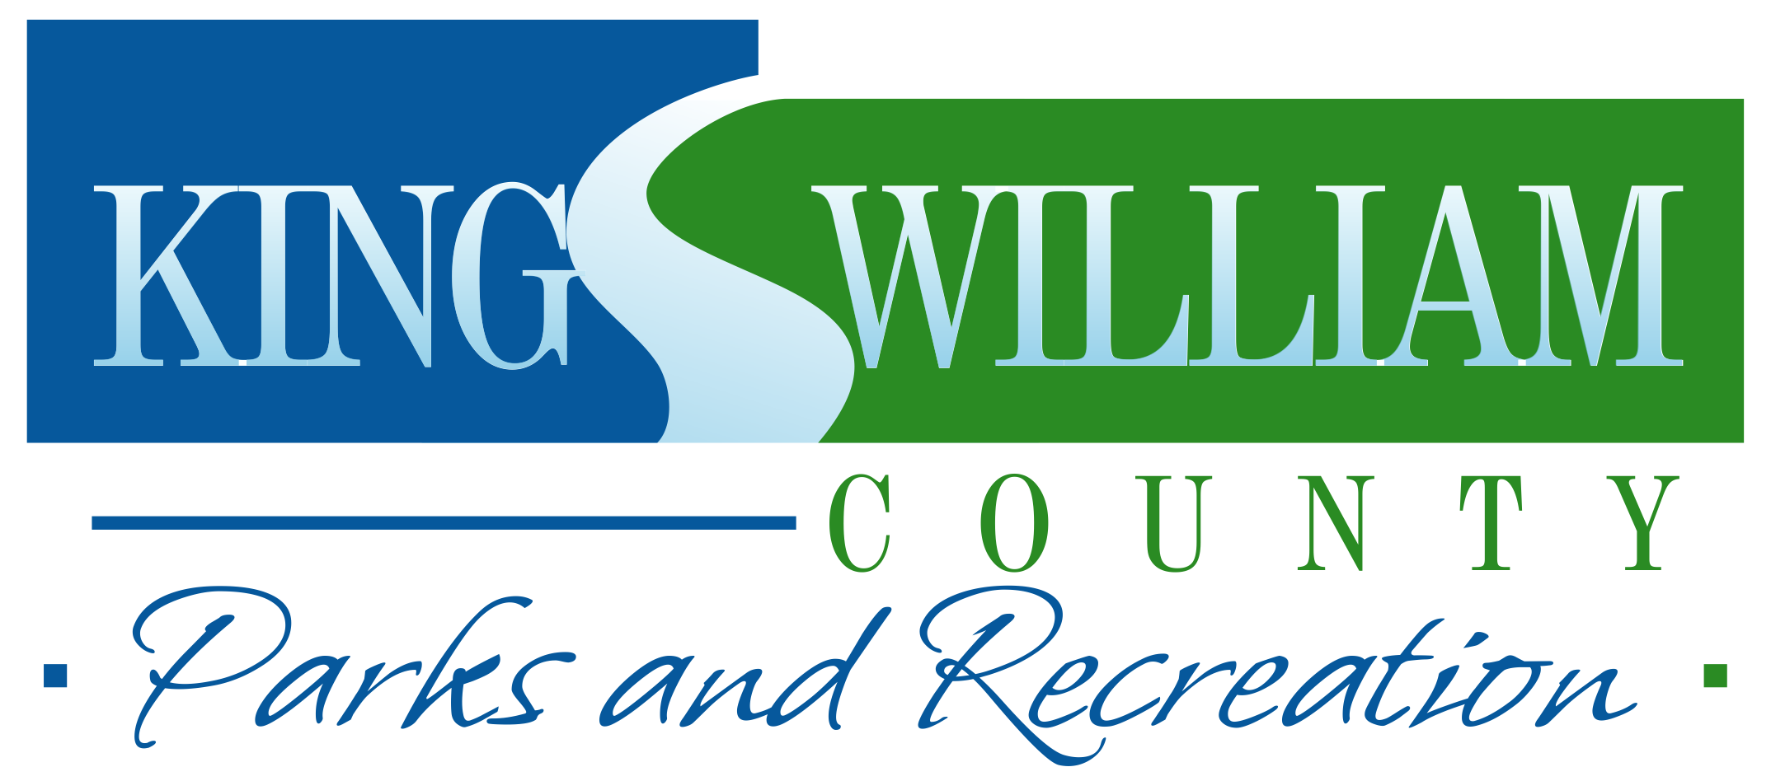
For Office Use Only:

Received: __________________
Staff: _________ Date: _______

check cash credit
Recreation Park
Reservation Form

Please mail or return this form, with check payable to “King William County” to the following locations:
Walk In/After Hours Drop Box Mail To:
Parks and Recreation Main Office King William County Parks and Recreation
180 Horse Landing Road PO Box 215
King William, VA 23086 King William, VA 23086
(804) 769-4981
Required Applicant Information (please print clearly)

Name: _______________________________ Organization/Company Name: _____________________________________

Address: ________________________________________ City: ____________________State: _________ Zip: __________

Phone #: (H) ____________________________ (W) ___________________________ (C) ______________________

E-mail: please note that confirmation will be emailed to this account __________________________________________________

Recreation Park Reservations

Name/Type of Event: _____________________________________________ Estimated Attendance:__________________

Reservation Area and Date: ____________________ 2nd Choice: ____________________ 3rd Choice: _________________
(see below for list of Park Areas)
Estimated Time of Usage: FROM: ________________________ am/pm TO: ______________________ am/pm
Non-lighted areas are available between 10am-7pm
Fees Payment must be made at time of reservation.
King William County Resident: Any person, organization, company, etc. that is located within King William County

Non-Resident: Any person, organization, company, etc. that is located other than in King William County

Park Area | Max Capacity | Items Included | Resident/ Non-Resident
Fields 1 and 4 | N/A | 300’ fence | $25/ $25  $50 for lighting
Field 2 | N/A | 200’ fence | $25/ $25  $50 for lighting
T-ball Field | N/A | 150’ fence | $25/ $25  $50 for lighting
Basketball Courts | N/A | 2 courts | FREE (Reservation Form still required)
Shelter | 50 | 4 picnic tables | $15/ $30

ALCOHOLIC BEVERAGES ARE PROHIBITED ON COUNTY PROPERTY
Special equipment shall not be installed without written permission from the Director of Parks & Recreation.
Under no circumstances will commercial amusements be allowed (blow-up slides, moon bounces, etc).
Please help keep the shelter areas and our park clean for the next user group.

By signing below, you are agreeing to adhere to all Parks & Recreation site rules and regulations.

Signature: ______________________________________________________ Date: __________________________

Recreation Park Reservations
Park Areas, Rules and Regulations

Fields 1 and 4
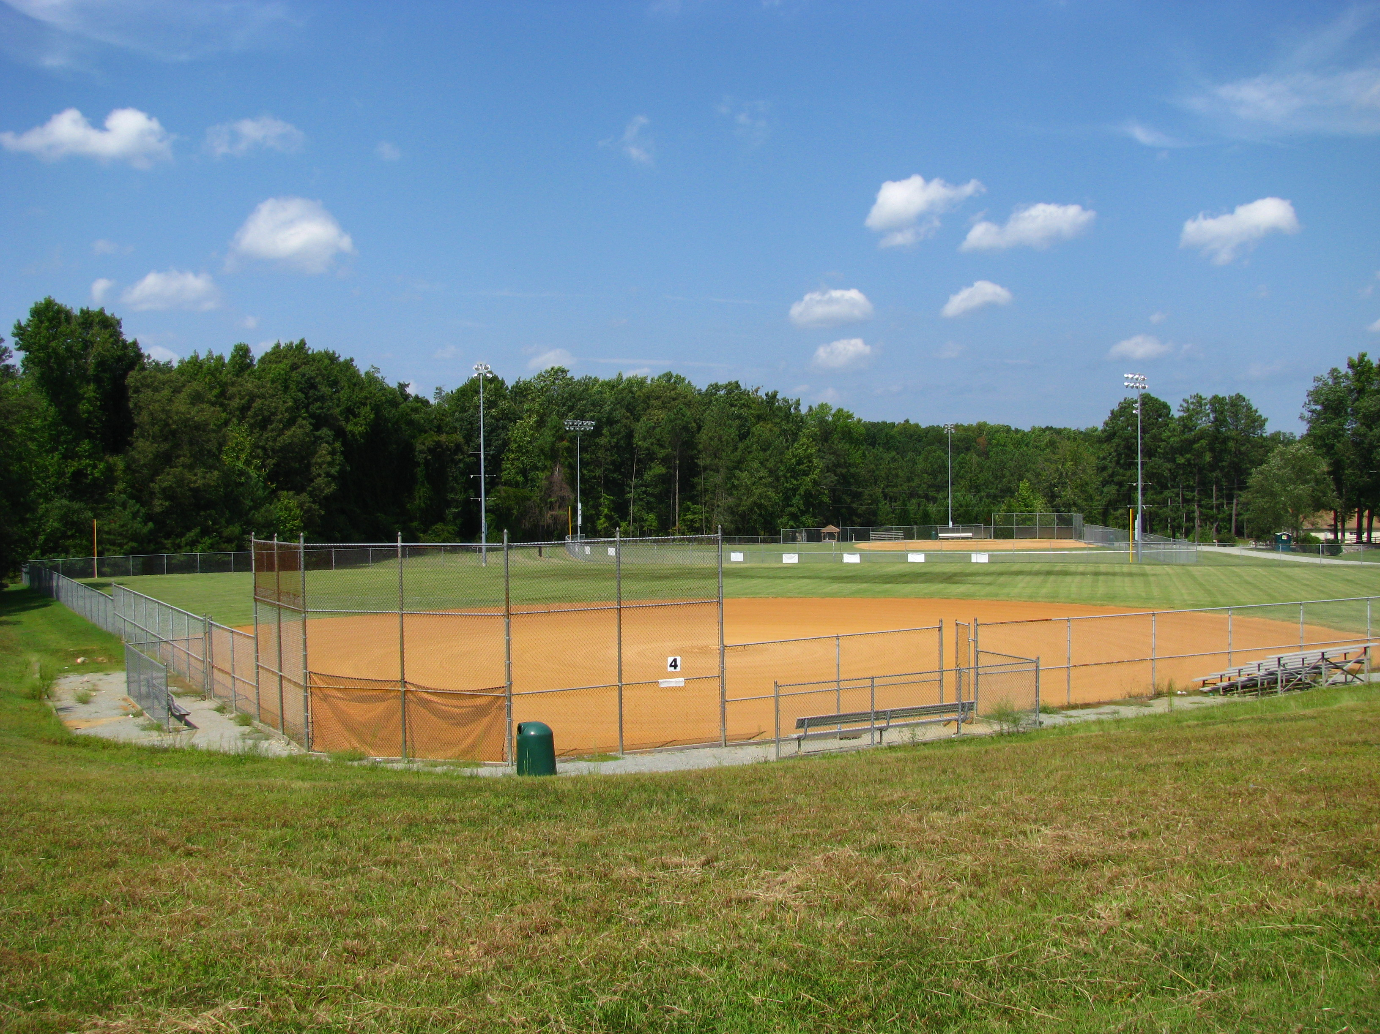
300’ fence $25 (R/NR) $50 lighting

Rules and Regulations

Persons requesting the reservation of a park area in the County must complete a Recreation Park Reservation Form and return it to the Dept. of Parks and Recreation.
- Reservation usage in non-lighted areas is allowed between 10am and 7pm daily.
- Refunds will be granted one week prior to the reservation date, after which no refunds will be allowed. Refunds will not be made due to inclement weather. All refund requests MUST be submitted in writing to the Parks and Recreation office.
- The Recreation Park is open throughout the entire year, but only certain Park Areas are open after daylight hours. When King William County Public Schools close due to inclement weather, the Recreation Park will also be closed.
- King William Parks and Recreation reserves the right to refuse a request to use any Park Area, and will notify applicants of such a decision in a timely manner.
- Upon receipt of completed Park Reservation Form, a Reservation Confirmation will be returned to the applicant. The applicant must then submit full payment and have this Reservation Confirmation in his/her possession on the day of the reservation.
- The picnic area (not the reserved Shelter) shall be available to the public on a first come, first served basis at no charge.
- Shelter attendance shall not exceed the maximum capacity stated on the Recreation Park Reservation Form.
- Any cleanup or damage to the Park Areas is the responsibility of the applicant. The applicant will be billed if this responsibility is not met.
- The applicant is completely responsible for damages, accidents, and injuries. The applicant agrees to save King William County harmless from any and all accidents and injuries occurring during the use of park facilities. King William County will not be held responsible for any loss or theft during the use of park facilities.
- All fires must be in a grill; ground fires are strictly prohibited.
- Special equipment shall not be installed without written permission from the Director of Parks and Recreation. Under no circumstances will commercial amusements be allowed (blow-up slides, etc).

Field 2
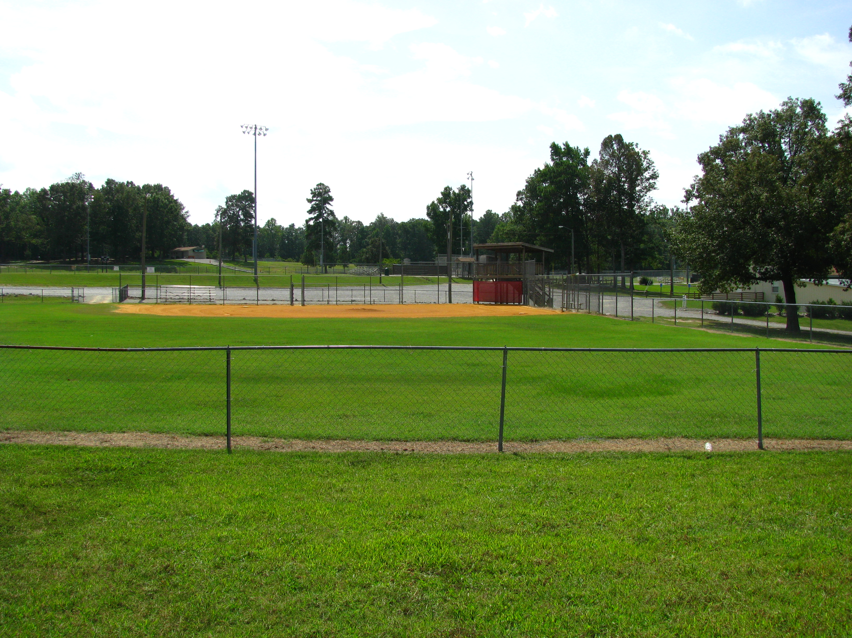
200’ fence $25 (R/NR) $50 lighting

The King William Recreation Park is patrolled by the King William Sheriff’s Department.
Sheriff Dept non-emergency: 804-769-0999
Shelter
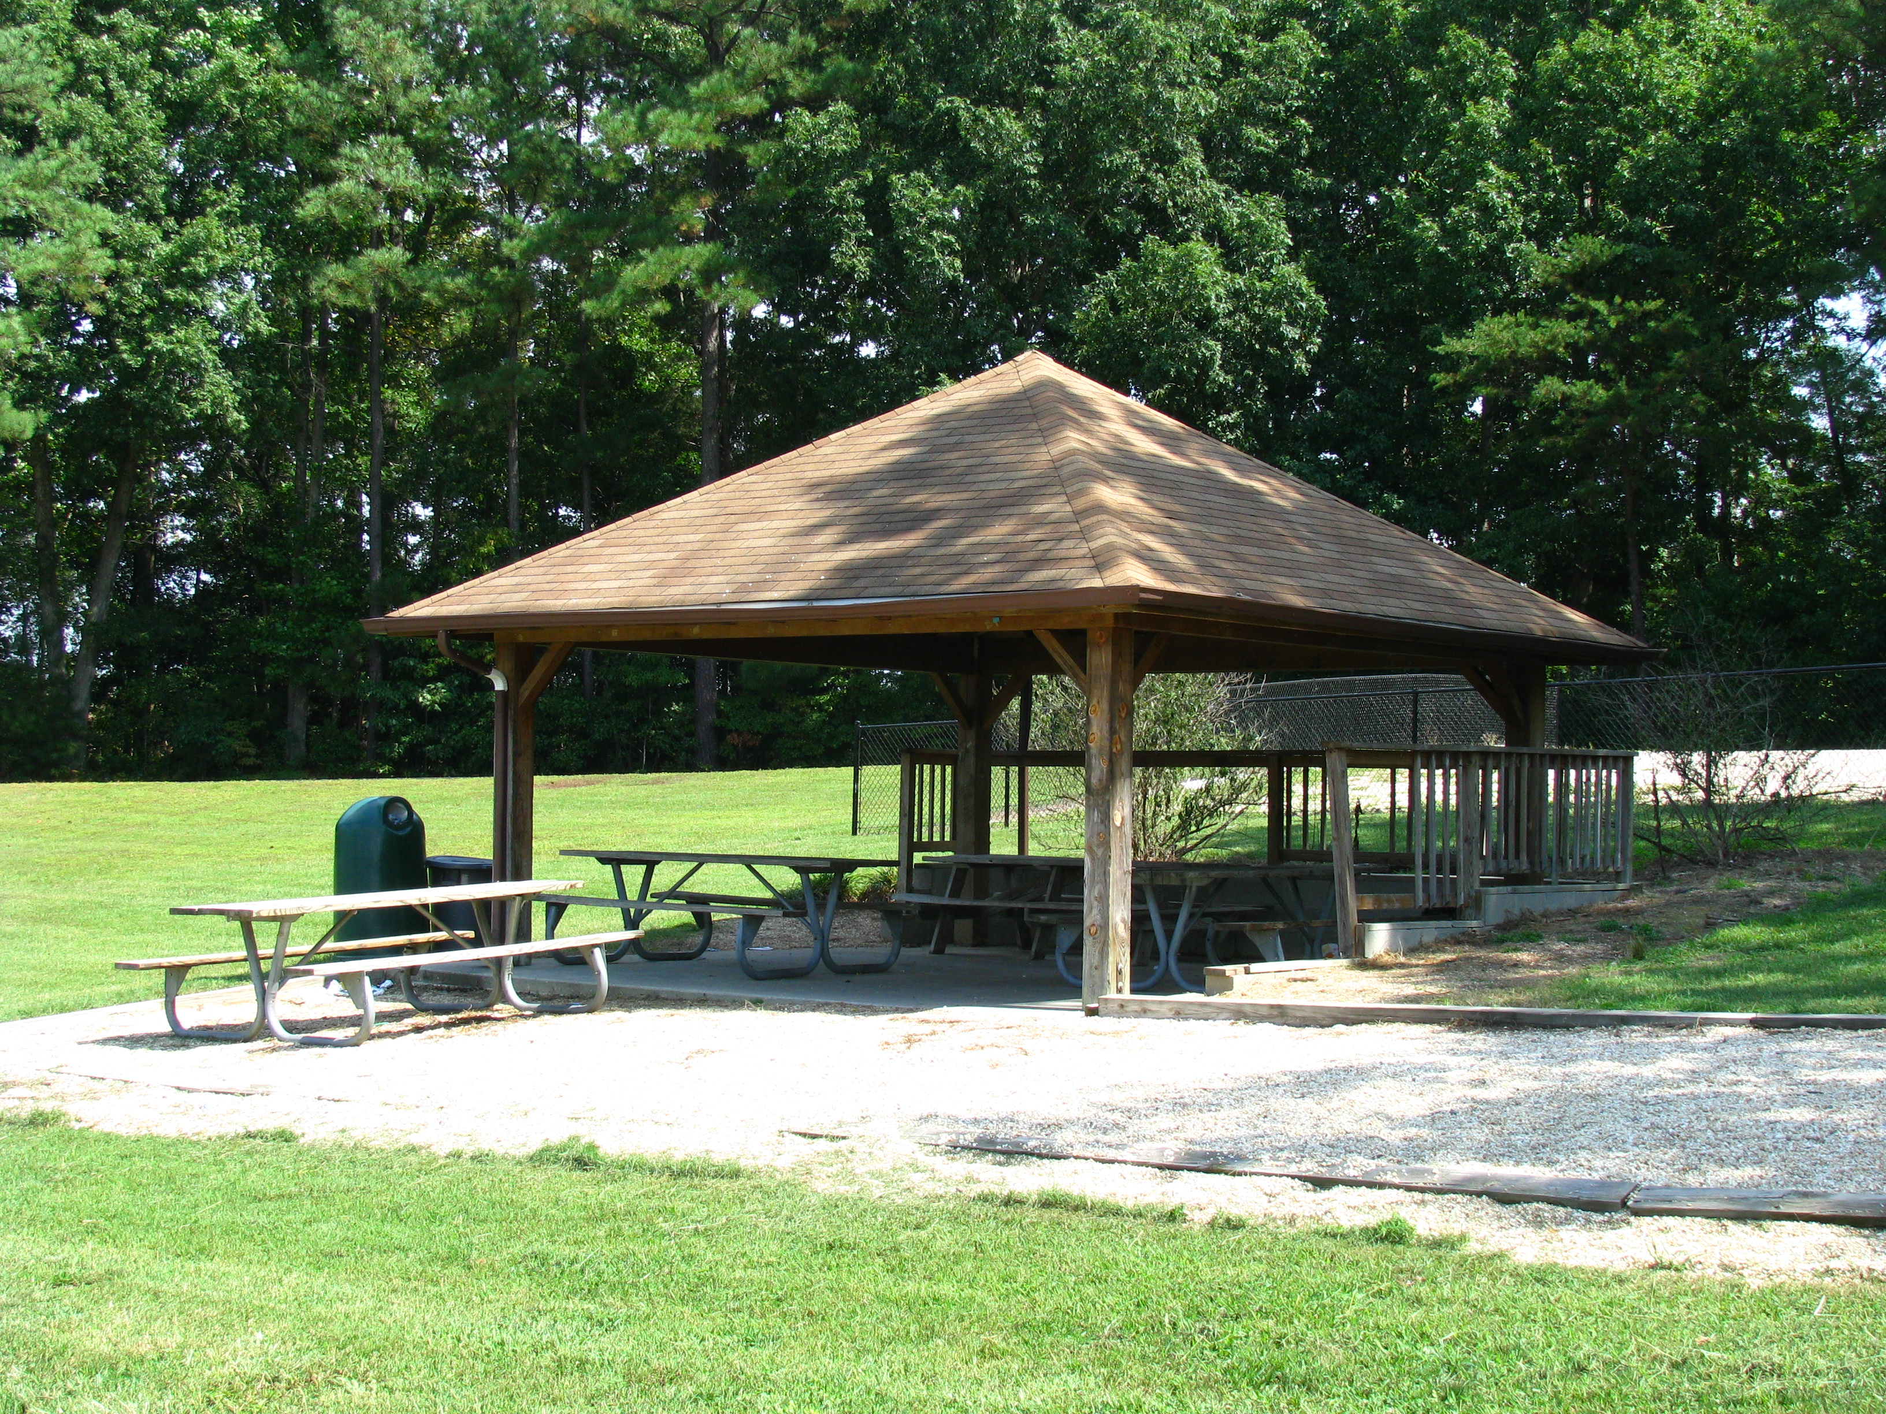
4 picnic tables $15 (R) $30 (NR)
T-Ball Fields
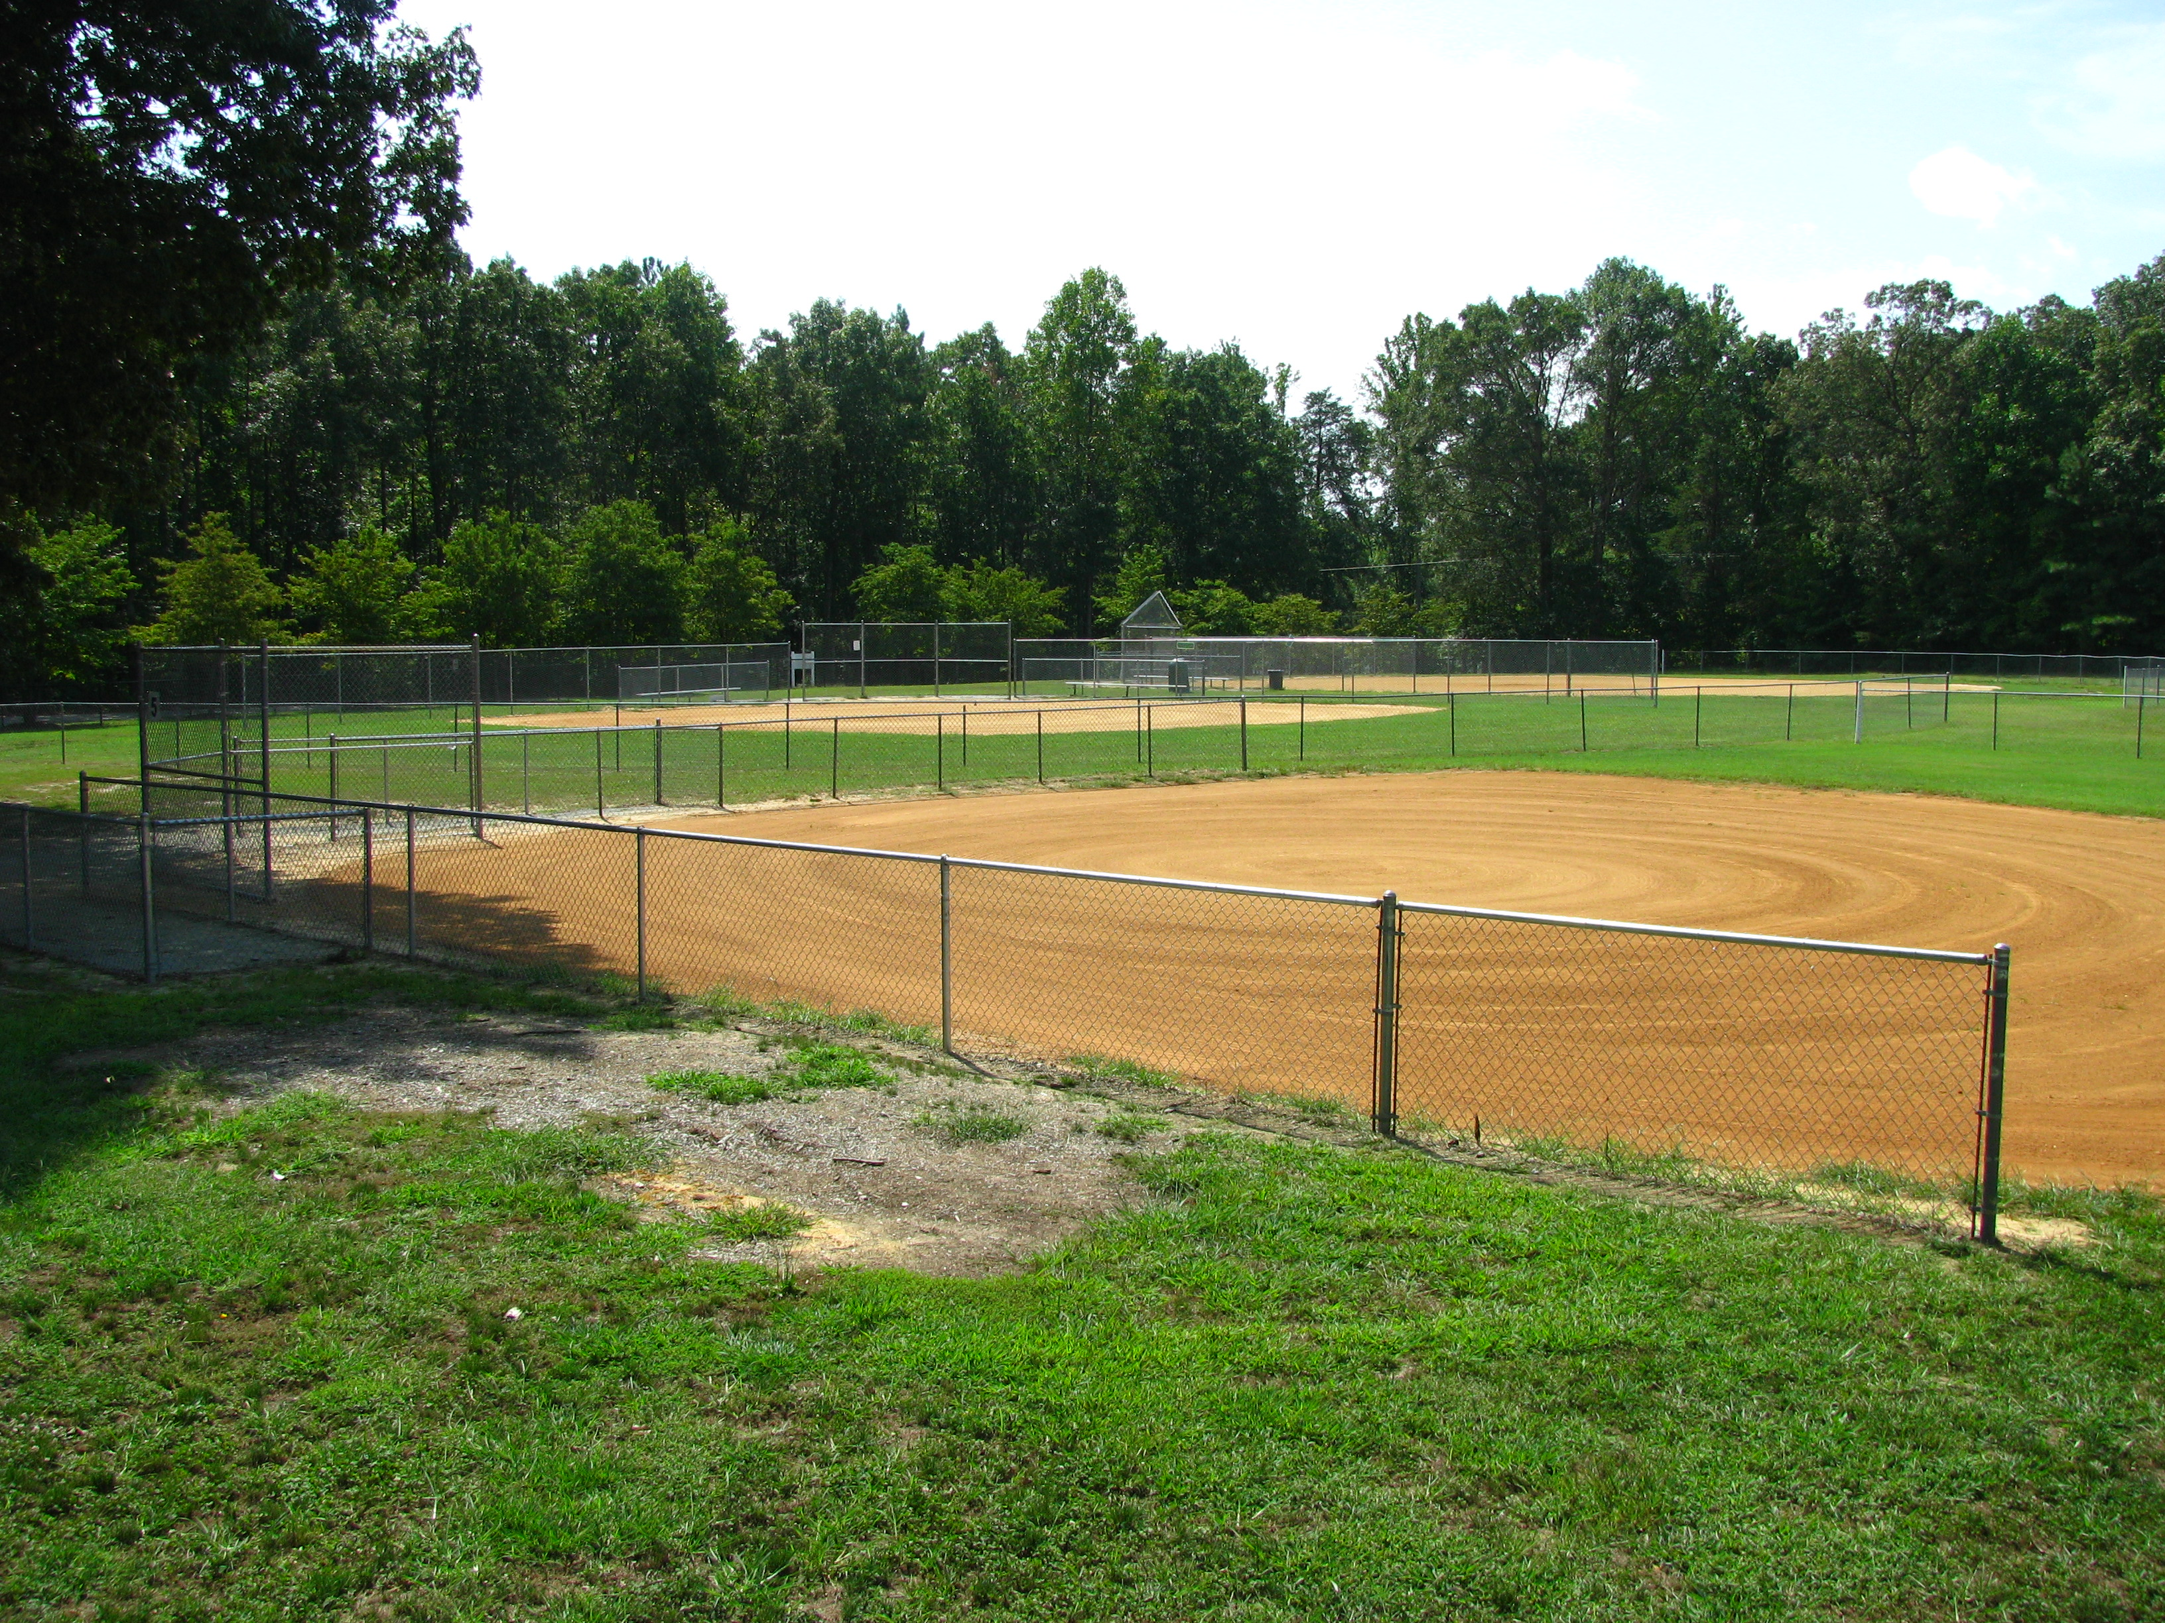
150’ fence $25 (R/NR) $50 lighting
Basketball Courts
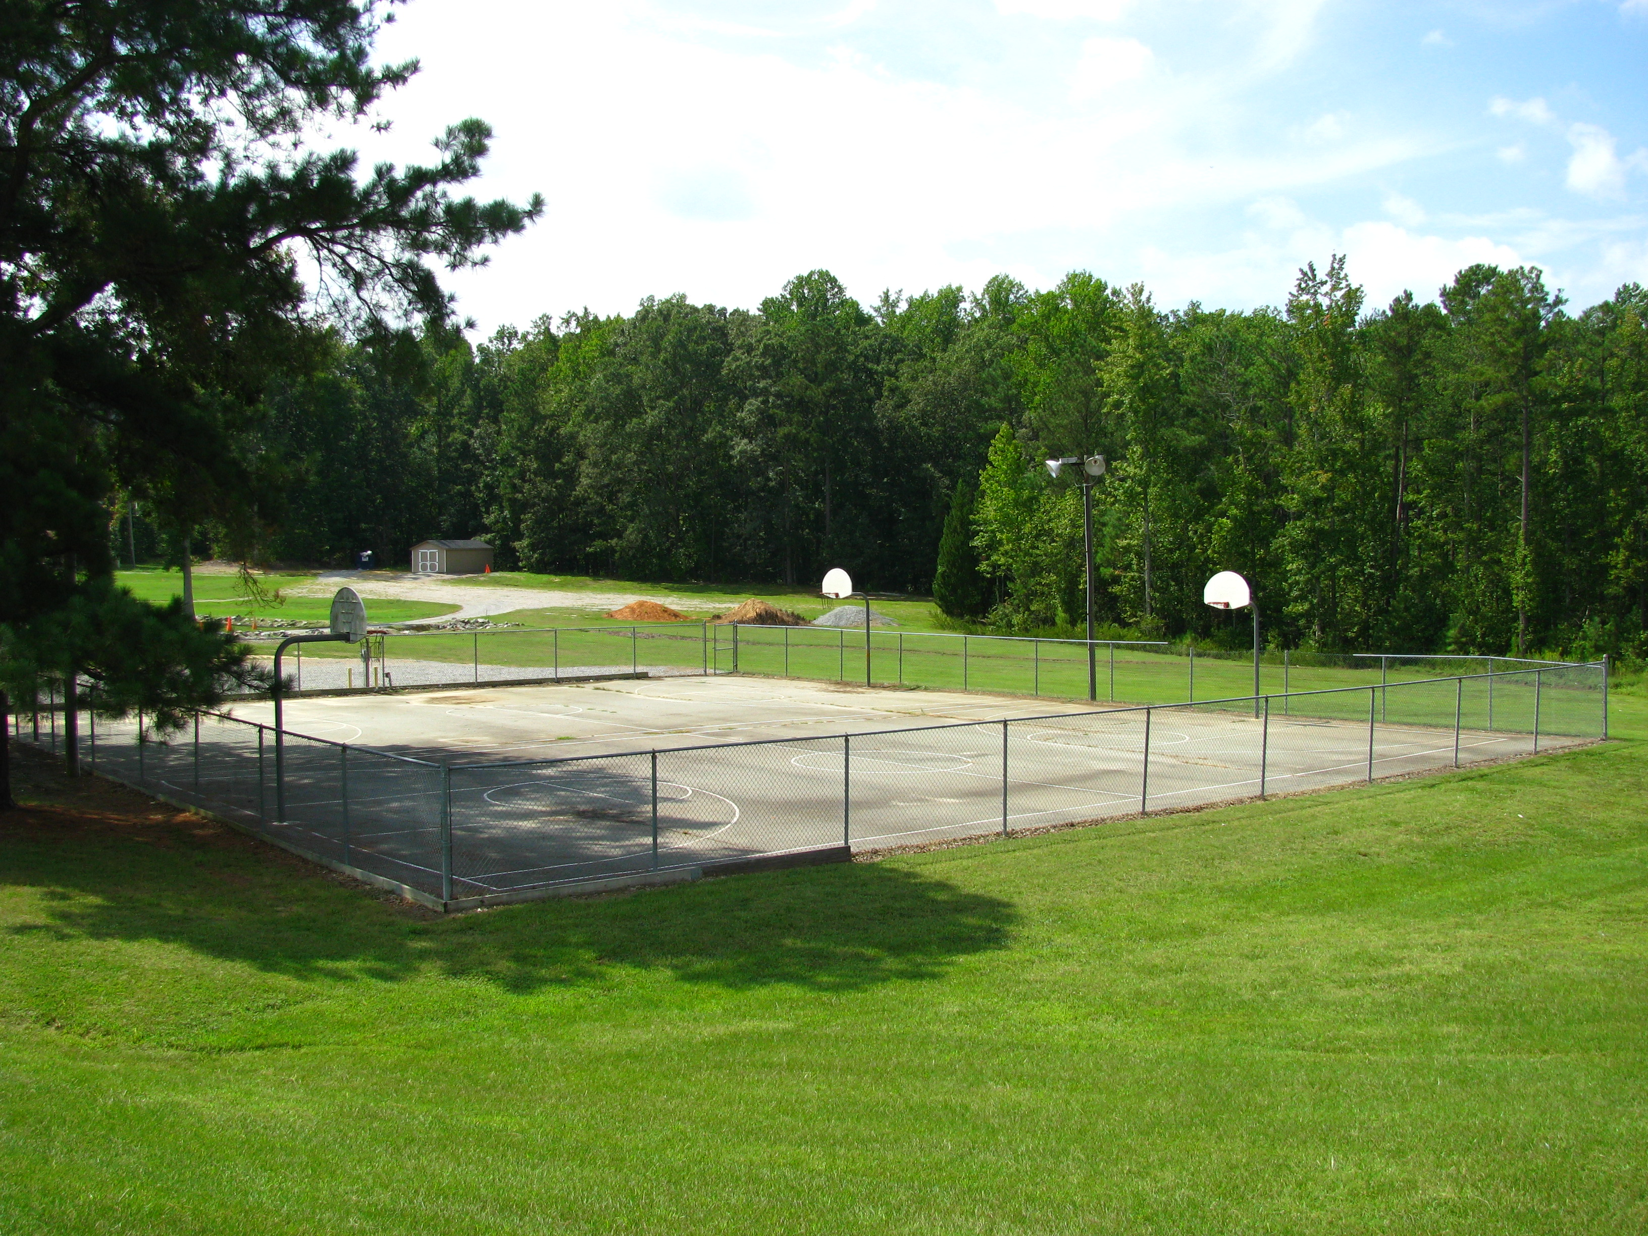
2 courts FREE

